

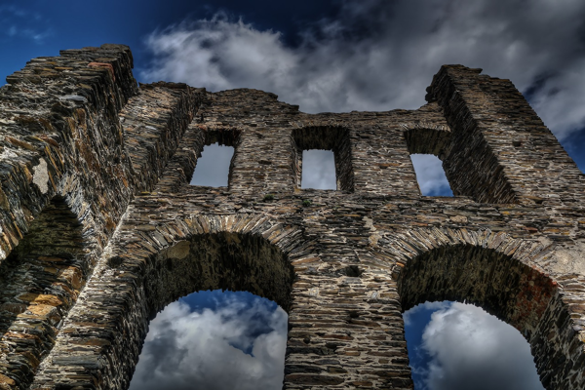

**Day 2: Delhi’s Heritage Unfolded**

Travel Time Distance: Local transit, minimal travel.   
Start your day with a visit to the magnificent Red Fort. Then, explore Humayun’s Tomb, a UNESCO site. For lunch, relish traditional curries in Chandni Chowk. In the afternoon, we’ll head to Qutub Minar, the tallest brick minaret in the world. End the day at the Lotus Temple, witnessing its architectural marvel as the sun sets.   
  
---